PLANT CARE

A MINI-PROJECT REPORT

**Submitted by**

**LOGESH D - 2116220701144**

***in partial fulfilment of the award of the degree***

***of***

# BACHELOR OF ENGINEERING

**IN**

**COMPUTER SCIENCE AND ENGINEERING**



# RAJALAKSHMI ENGINEERING COLLEGE

**AUTONOMOUS, CHENNAI**

**NOV-DEC 2024**

### 

### BONAFIDE CERTIFICATE

Certified that this mini project “**Plant Care**” is the Bonafide work of “**LOGESH D**

**(2116220701144)”** who carried out the project work under my supervision.

|  |  |
| --- | --- |
| **SIGNATURE** | |
| Mrs. JANANEE V, | |
| Assistant Professor, | |
| Computer Science Engineering | |
| Rajalakshmi Engineering College | |
| Thandalam, Chennai -602105. | |
|  | |

Submitted for the End semester practical examination to be held on

**INTERNAL EXAMINER EXTERNAL EXAMINER**

### ACKNOWLEDGEMENT

I express my sincere thanks to my beloved and honourable chairman

MR.S.MEGANATHAN and the chairperson DR.M.THANGAM MEGANATHAN for their timely support and encouragement.

I am greatly indebted to my respected and honourable principal Dr. S.N.MURUGESAN for his able support and guidance.

No words of gratitude will suffice for the unquestioning support extended to us by my head of the department Dr. P. KUMAR, and my Academic Head Dr.B.SABITHA, for being ever supporting force during my project work.

I also extend my sincere and hearty thanks to my internal guide

Mrs. JANANEE V for her valuable guidance and motivation during the completion of this project.

My sincere thanks to my family members, friends and other staff members of Computer Science and Engineering.

## 

## ABSTRACT

This project presents an innovative platform designed to enhance plant care through technology. By integrating image recognition, users can upload photos of plants to receive instant identification and detailed care instructions. The platform features a user-friendly interface that allows users to click on specific plant images for in-depth information, including care tips, optimal growing conditions, and common issues. Additionally, the project includes curated articles and instructional videos, providing users with comprehensive resources to support their plant care journey. This holistic approach not only educates users but also fosters a community of plant enthusiasts, encouraging sustainable practices and a deeper connection with nature.

The platform’s interactive design includes clickable images that lead to extensive resources on each plant species. Users can explore a wealth of information, including common pests and diseases, propagation methods, and seasonal care tips. To further enrich the user experience, the project features a curated selection of articles and instructional videos, providing practical advice and expert insights.

By fostering a community of plant enthusiasts, this platform aims to promote sustainable gardening practices and encourage users to share their experiences and knowledge. The integration of technology in plant care not only enhances user engagement but also supports the growing trend of urban gardening and indoor plant care, contributing to environmental awareness and the importance of biodiversity.

This project serves as a valuable resource for both novice gardeners and seasoned plant lovers, making plant care accessible, informative, and enjoyable.

### TABLE OF CONTENTS

**CHAPTER NO. TITLE PAGE**

**ABSTRACT 4**

**1. INTRODUCTION 6**

**1.1. SCOPE OF THE WORK 6**

**1.2. AIM AND OBJECTIVES OF THE PROJECT 7**

**2. SYSTEM SPECIFICATIONS 8**

**2.1. SOFTWARE SPECIFICATIONS** **8**

**3. ARCHITECTURE DIAGRAM 9**

**4. MODULE DESCRIPTION 10**

**5. SYSTEM DESIGN 12**

**5.1. USE CASE DIAGRAM 12**

**5.2. ER DIAGRAM 13**

**5.3. DATA FLOW DIAGRAM 14**

**5.4. ACTIVITY DIAGRAM** **15**

**6. SAMPLE CODIND 16**

**7. SCREEN SHOTS 20**

**8. CONCLUSION 30**

**REFERENCES 31**

## CHAPTER 1

### INTRODUCTION

1. **INTRODUCTION**

In recent years, the popularity of indoor and urban gardening has surged, leading to a growing interest in plant care among individuals of all ages. However, many aspiring gardeners face challenges in identifying plant species and understanding their specific care requirements. This project addresses these challenges by creating a comprehensive platform that integrates image recognition technology, detailed plant information, and educational resources. By simplifying the plant care process, this platform aims to foster a deeper connection between users and their plants, ultimately promoting sustainable gardening practices and enhancing overall plant health.

* 1. **SCOPE OF THE WORK**

The scope of this project encompasses the development of a user-friendly web-based application designed for plant care enthusiasts. Key features of the platform include:

1. **Image Recognition**: Users can upload images of plants for instant identification.
2. **Clickable Plant Details**: Each identified plant will have a dedicated page with essential care information.
3. **Educational Resources**: The platform will host articles and videos on plant care techniques, troubleshooting common issues, and understanding plant biology.
4. **User Community**: An interactive space for users to share experiences, tips, and advice on plant care.

This project will primarily target novice gardeners and urban dwellers interested in enhancing their gardening skills and knowledge.

* 1. **AIM AND OBJECTIVES OF THE PROJECT**

### Aim: The primary aim of this project is to create an interactive and informative platform that empowers users to care for their plants effectively through the use of technology and accessible educational resources.

### Objectives:

### To Develop an Image Recognition System: Implement a reliable image recognition feature that allows users to accurately identify plants from uploaded photos.

### To Provide Comprehensive Plant Care Information: Create detailed profiles for various plant species, including care instructions, environmental needs, and potential problems.

### To Curate Educational Content: Assemble a library of articles and videos that cover a wide range of topics related to plant care, ensuring users have access to reliable information.

### To Foster a Community of Plant Enthusiasts: Establish a platform where users can interact, share experiences, and seek advice from fellow plant lovers.

### To Promote Sustainable Gardening Practices: Encourage environmentally friendly gardening habits through educational resources and community engagement.

### CHAPTER 2

**2. SOFTWARE SPECIFICATIONS**

|  |  |  |
| --- | --- | --- |
| Operating System | **:** | WINDOWS 11 |
| Front – End | **:** | HTML,CSS,JAVASCRIPT,SCSS,PHP |
| Back – End | **:** | PHP, MYSQL |

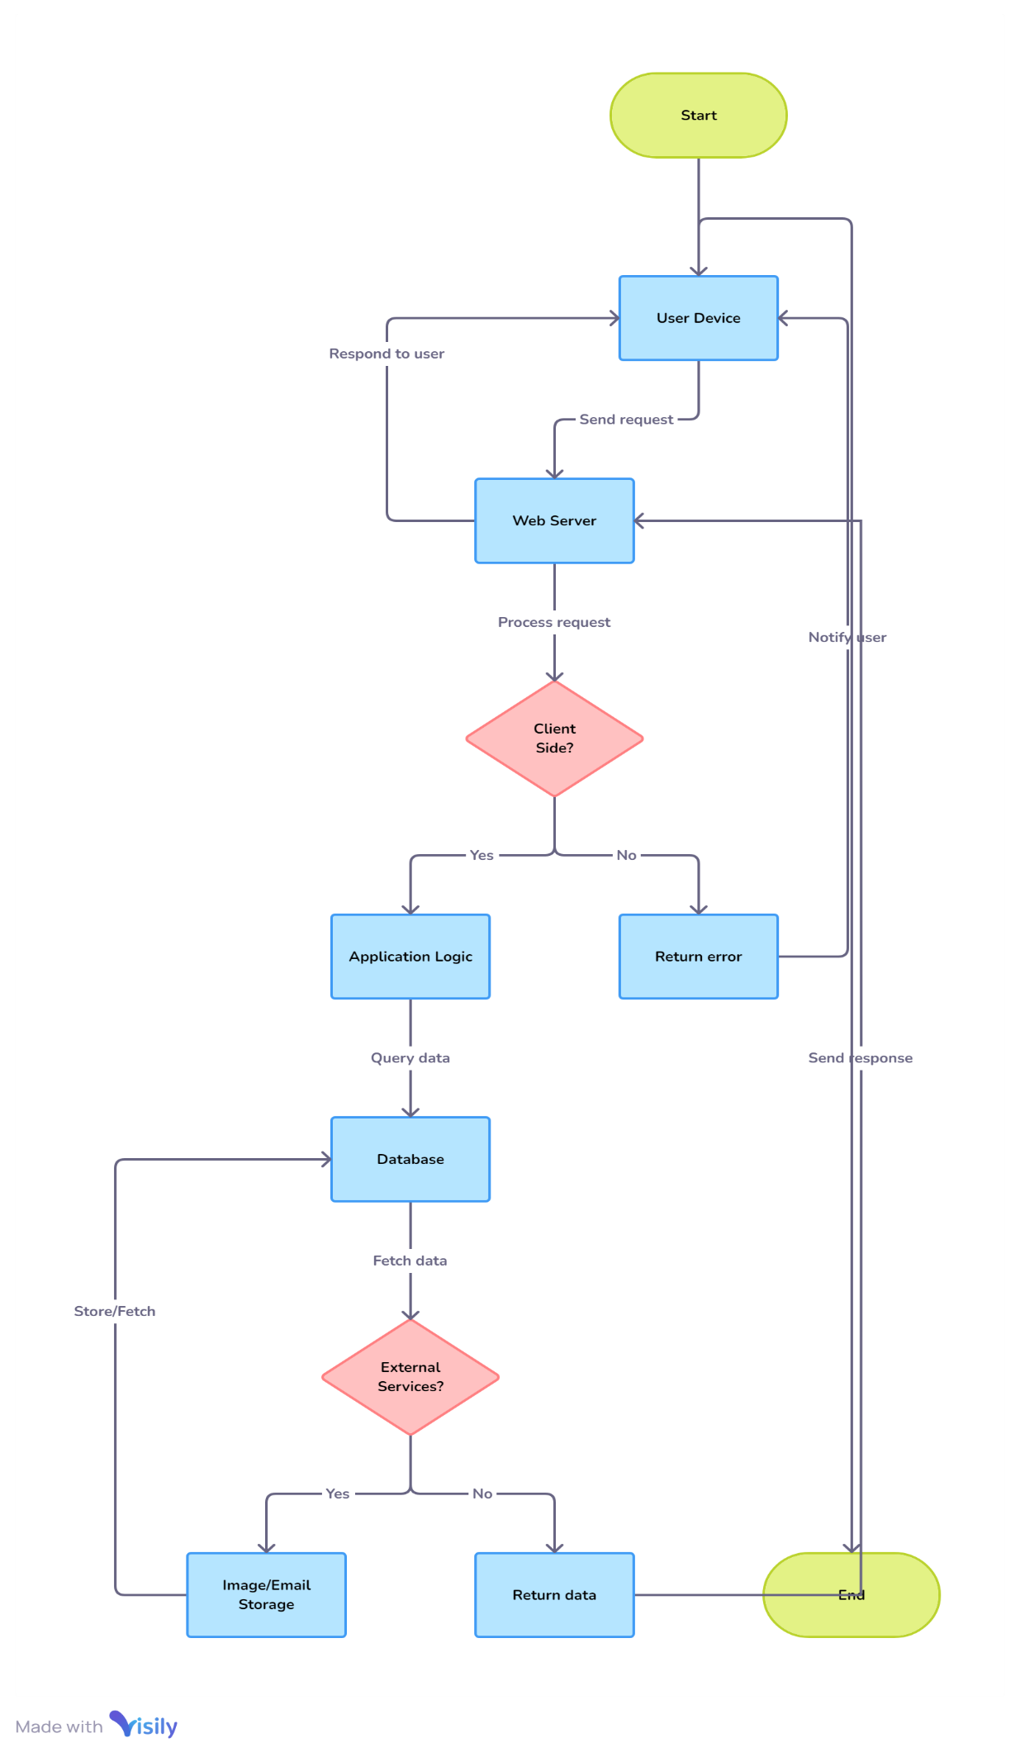**CHAPTER 3**

**ARCHITECTURE DIAGRAM**

**CHAPTER 4 MODULE DESCRIPTION**

**4.1. User Registration and Login Module:**

The User Registration and Login Module for the Plant Care Management System is

designed to provide secure and efficient access to authorized users, including gardeners,

plant enthusiasts, and administrators. Users can create profiles with essential

information, undergo verification processes, and receive role-based access, ensuring

accountability and data integrity.

**4.2. Plant Database Module:**

Plant Database Module within the Plant Care Management System serves as a comprehensive repository, providing users with a detailed inventory of plant species, care instructions, and resources for plant maintenance. This module facilitates efficient management and access to information, ensuring that users have the necessary tools and knowledge for successful plant care.

**4.3. Care Tips Module:**

The Care Tips Module in the Plant Care Management System provides a dynamic and real-time overview of best practices for plant maintenance. It efficiently tracks common care queries, seasonal advice, and user-generated tips, prioritizing information based on plant types and user preferences. The module incorporates a feedback system, ensuring continuous improvement in the quality of care recommendations.

**4.4. Admin Module:**

The Admin Module within the Plant Care Management System serves as the command center, equipping administrators with essential tools for overseeing and managing the entire spectrum of activities. It enables efficient user management, allowing the addition, modification, and deactivation of accounts with diverse roles and permissions. The module provides a comprehensive dashboard with analytics and reporting capabilities, facilitating data-driven decision-making and community engagement. Administrators can configure system settings, manage the plant database, and communicate critical updates to users. With robust security features, incident response tools, and collaboration functionalities, the Admin Module ensures a coordinated, secure, and adaptive response to user needs, maintaining the integrity and efficiency of the plant care management system.

# CHAPTER 5

**SYSTEM DESIGN**

**5.1 USE CASE DIAGRAM**

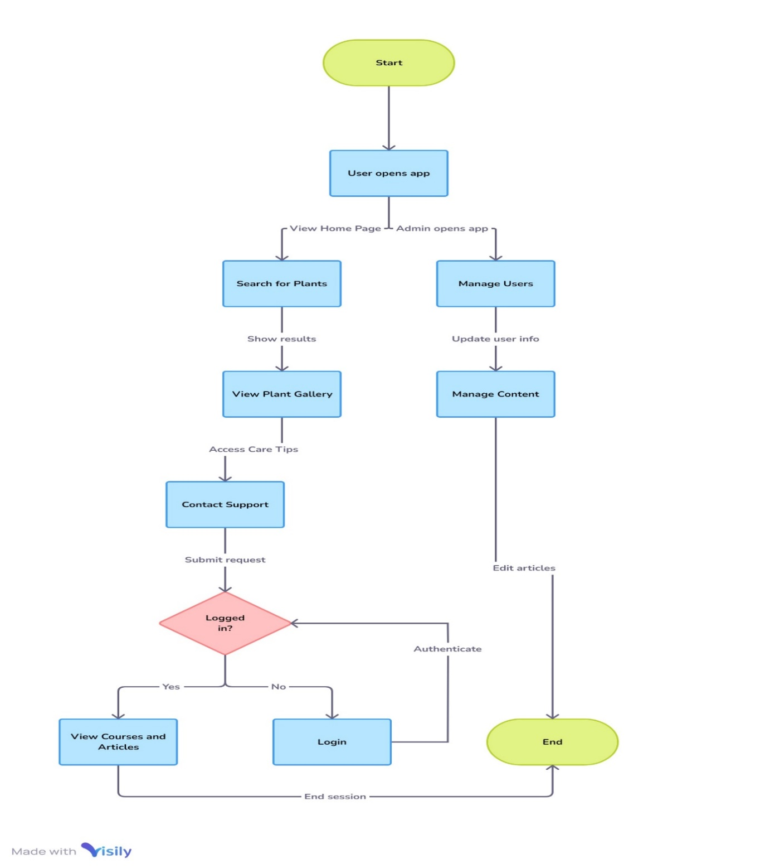

**5.2 ER DIAGRAM**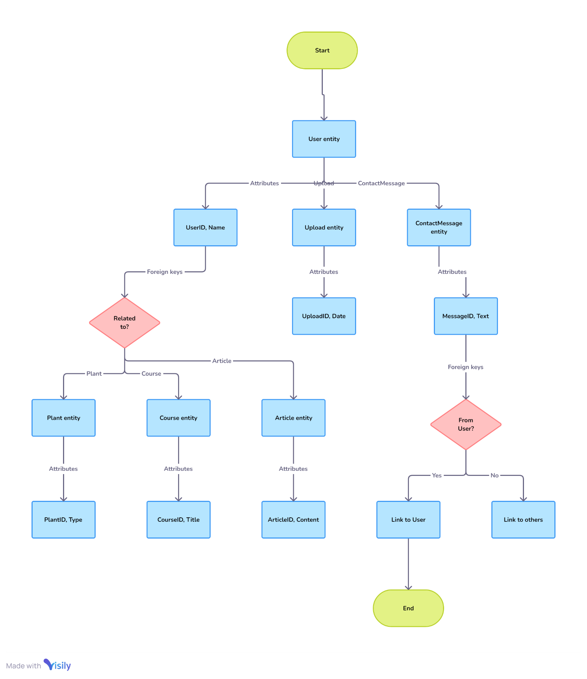

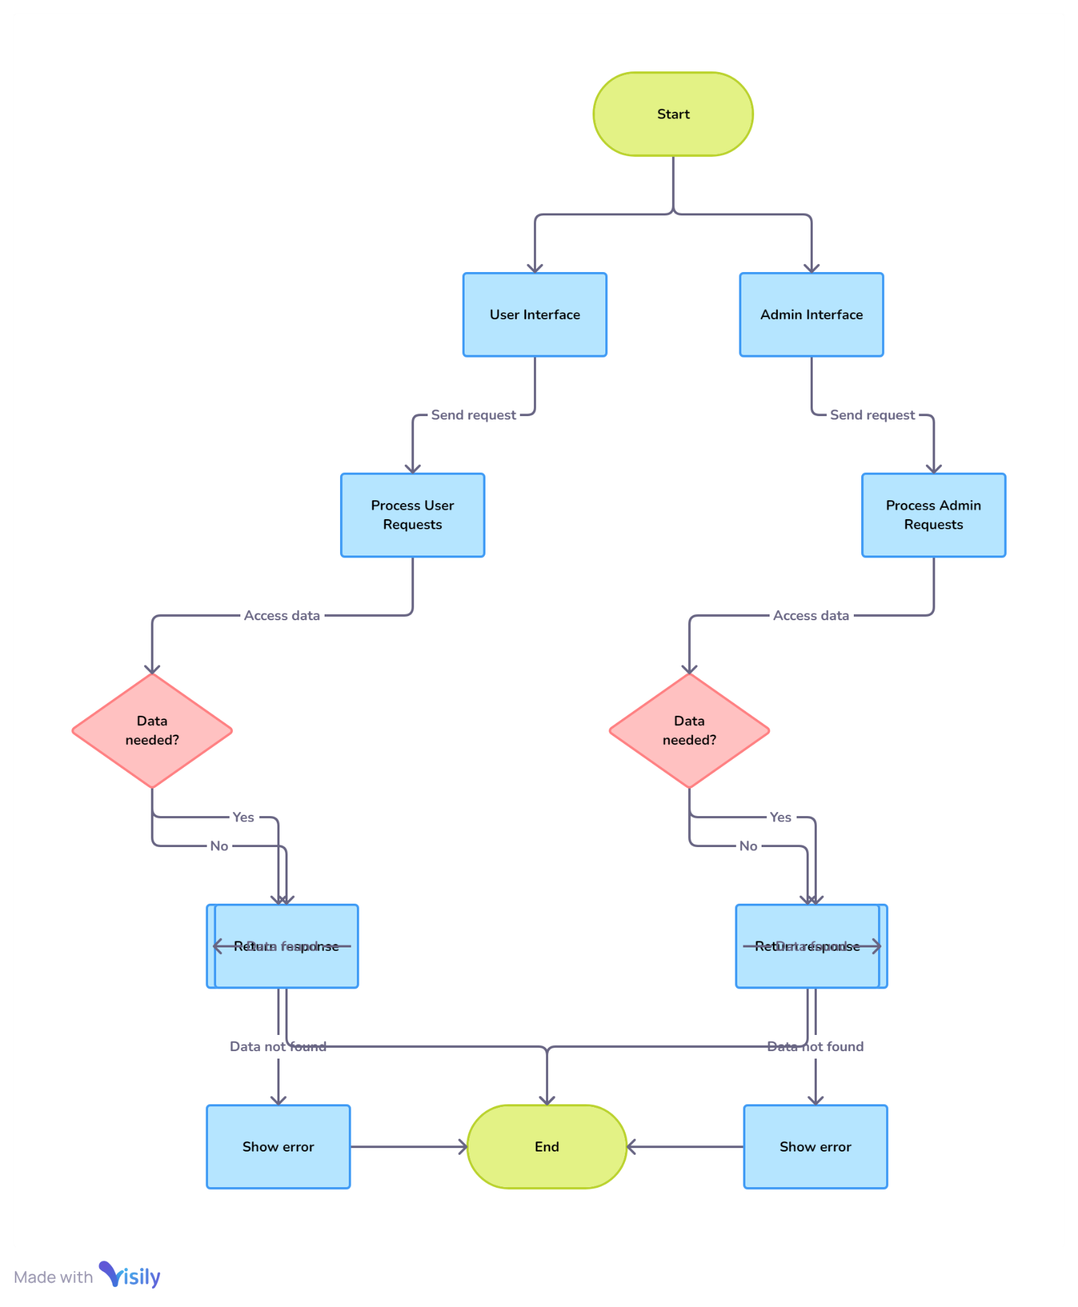**5.3 DFD DIAGRAM**

**5.4 ACTIVITY DIAGRAM**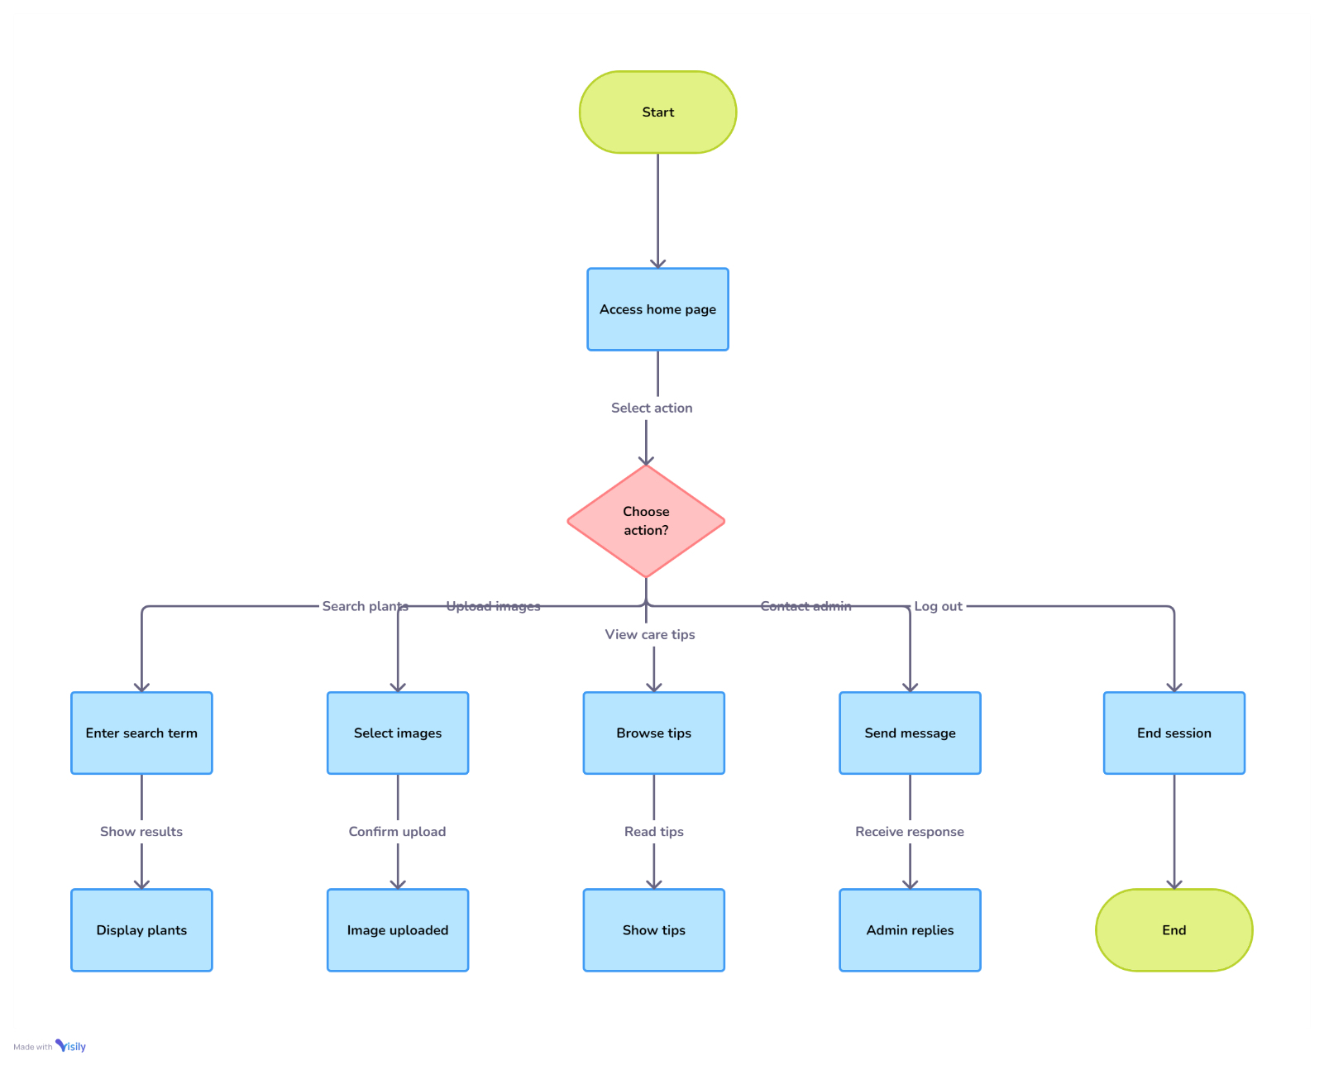

## CHAPTER 6

### SAMPLE CODING

<!DOCTYPE *html*>

<html lang="en">

<head>

<meta charset="UTF-8">

<meta name="viewport" content="width=device-width, initial-scale=1.0">

<img src="images\Green_and_White_Plants_Organic_Logo-removebg-preview.png" style="display: block; margin: 0 auto;">

<title>Plant Care</title>

<link href="pro1.css" rel="stylesheet" type="text/css">

<link href="https://cdn.jsdelivr.net/npm/remixicon@2.5.0/fonts/remixicon.css" rel="stylesheet">

<link href="https://fonts.googleapis.com/css2?family=Roboto:wght@400;700&display=swap" rel="stylesheet">

<link rel="stylesheet" href="styles.css">

<link rel="stylesheet" href="styles.scss">

</head>

<body>

</head>

<body>

<header>

<h1>Plant Care Guide</h1>

<nav>

<ul>

<li><a href="#home">Home</a></li>

<li><a href="#plants">Plants</a></li>

<li><a href="#tips">Care Tips</a></li>

<li><a href="#contact">Contact</a></li>

<li><a href="login.html">Login</a></li>

</ul>

</nav>

<div id="time"></div>

</header>

<script>

function updateTime() {

const options = { timeZone: 'Asia/Kolkata', hour: '2-digit', minute: '2-digit', second: '2-digit' };

const timeString = new Date().toLocaleTimeString('en-IN', options);

document.getElementById('time').textContent = timeString;

}

setInterval(updateTime, 1000);

updateTime();

</script>

</head>

<body>

<section id="home" class="plant-care-section" style="margin-top: 200;" >

<h1>Welcome to Plant Care</h1>

<br>

<p>Your one-stop solution for all things plant care. Find your plant, or look up its care instructions and advice.</p>

</section>

<div class="container"  style="margin-top: 50;">

<form class="search" id="search-bar" action="search.php" method="GET">

<input type="search" placeholder="Type something..." name="q" class="search__input" id="search-input" required>

<div class="search__button" id="search-button">

<i class="ri-search-2-line search__icon"></i>

</div>

</form>

<div id="search-results" class="search-results"></div> <!-- Results Section -->

</div>

<script src="main.js"></script>

<div class="upload-section">

<h1>Upload an Image</h1>

<form method="POST" enctype="multipart/form-data" action="contact.php">

<input type="file" id="file-input" accept="image/*" />

<button class="upload-btn" id="submit-button">Submit</button>

</div>

</div>

<script>

const imageResponses = {

"rose": "Roses are a group of herbaceous flowering shrubs.",

"sunflower": "Sunflowers are known for their large flower heads and bright yellow petals.",

"tulip": "Tulips are spring-blooming perennials that grow from bulbs.",

"strawberry leaf scorch": `

Strawberry Leaf Scorch is a condition affecting strawberry plants, characterized by yellowing and browning of the leaf margins, leading to a scorched appearance. Here’s a brief overview:<br><br>

<strong>Causes:</strong><br>

- Environmental Stress: High temperatures and low humidity can contribute to scorch.<br>

- Water Stress: Inconsistent watering, either too much or too little, can cause leaf scorch.<br>

- Nutrient Deficiencies: Lack of essential nutrients, particularly potassium, can lead to this condition.<br>

- Disease: Certain pathogens, like viruses, can manifest as leaf scorch symptoms.<br><br>

<strong>Symptoms:</strong><br>

- Yellowing of leaf edges<br>

- Brown or burnt leaf tips<br>

- Curling or wilting of leaves<br>

- Premature leaf drop<br><br>

<strong>Management:</strong><br>

- Watering: Ensure consistent moisture without waterlogging.<br>

- Mulching: Helps retain soil moisture and regulate temperature.<br>

- Fertilization: Apply a balanced fertilizer to address nutrient deficiencies.<br>

- Disease Control: Regularly inspect plants for signs of disease and take appropriate measures (like removing infected plants).<br>

- Shade: Provide shade during extreme heat to protect plants from stress.<br><br>

<strong>Prevention:</strong><br>

- Choose heat-tolerant strawberry varieties.<br>

- Implement proper irrigation practices.<br>

- Monitor soil health and nutrient levels regularly.<br><br>

If you suspect your strawberries are suffering from leaf scorch, addressing the environmental and nutritional factors can often help restore plant health.

`

};

document.getElementById('submit-button').onclick = function() {

const fileInput = document.getElementById('file-input');

const file = fileInput.files[0];

if (file) {

const fileName = file.name.toLowerCase();

const response = getResponse(fileName);

// Create a new page to show the information

const newWindow = window.open('', '_blank');

newWindow.document.write(`

<html>

<head>

<title>Image Information</title>

</head>

<body>

<h1>Uploaded Image</h1>

<img src="${URL.createObjectURL(file)}" alt="Uploaded Image" />

<p>${response}</p>

</body>

</html>

`);

newWindow.document.close();

}

};

function getResponse(fileName) {

for (let key in imageResponses) {

if (fileName.includes(key)) {

return imageResponses[key];

}

}

return "Information not available for this image.";

}

</script>

<section id="plants" style="margin-top: -10px;">

<h2>Rare Plants</h2>

<br>

<img src="images\Nature YouTube Banner in White Minimalist Photo Style.png" height="200" width="1230">

<br>

<style>

div {

display: flex;

justify-content: center;

align-items: center;

flex-wrap: wrap;

}

div img {

width: 400px;

height: 300px;

border: 2px solid #ff3d0036;

border-radius: 13px;

box-shadow: 4px 7px 7px 0px #00000042;

cursor: pointer;

margin: 10px;

transition: 400ms;

}

div img:hover {

filter: grayscale(1);

transform: scale(1.03);

}

</style>

<br>

<div>

<a href="page1.html">

<img src="images\ypmpp7g5b5l61.jpg" alt="Clickable Image" id="clickableImage">

</a>

<img src="images\Welwitschia_mirabilis(2).jpg">

<img src="images\qqq_craanagvn-onlyvfvnan-13o.400x400-u0c0i1s1q90f1.jpg">

<img src="images\f31df6d953a0c34d8d754916167ae2a5.lg_-e1595214340674.jpg">

<img src="images\dfb98b_6d947a33143b477bb8bebc4fdc7a9a13~mv2.webp">

<img src="images\Attlwr.jpg">

<img src="images\2021corpseflowerusbg.jpg">

<img src="images\330px-Paphiopedilum_rothschildianum_(25834537567).jpg">

<img src="images\330px-Jade_vine_(70200).jpg">

<img src="images\330px-Encephalartos_woodii_original_stem_Durban_Botanic_Gardens_04_09_2010.jpeg">

</div>

</section>

<section id="tips" style="margin-top: -50px;">

<h2>Plant Care Tips</h2>

<br>

<div class="tips-content"></div>

<h3>Video Courses</h3>

<li><a href="index.php" target="_blank">Introduction to Plant Care</a></li>

<li><a href="https://www.example.com/course2" target="_blank">Advanced Gardening Techniques</a></li>

<li><a href="https://www.example.com/course3" target="_blank">Sustainable Planting Practices</a></li>

<div class="tips-content"></div>

<h3>Articles</h3>

<li> <a href="articles1.html" target="_blank">The Ultimate Guide to Indoor Plants</a></li>

<li>  <a href="https://www.example.com/article2" target="_blank">Top 10 Low Maintenance Plants</a></li>

<div class="gif-container" style="margin-top: -300px;">

<img src="videos\Green Plant Care Plan Instagram Story Video.gif" alt="Description of GIF"  >

</div>

<section id="contact" style="margin-top: -10px;">

<h2>Contact Us</h2>

<form id="contact-form" method="POST" action="contact.php">

<div class="form-group">

<label for="name">Name:</label>

<input type="text" id="name" name="name" required>

</div>

<div class="form-group">

<label for="email">Email:</label>

<input type="email" id="email" name="email" required>

</div>

<div class="form-group">

<label for="message">Message:</label>

<textarea id="message" name="message" required></textarea>

</div>

<button type="submit">Send</button>

</form>

</section>

<br><footer> <p>&copy; 2024 Plant Care. All rights reserved.</p>

## CHAPTER 7

**SCREEN SHOTS**



Fig. 7.2 User Login

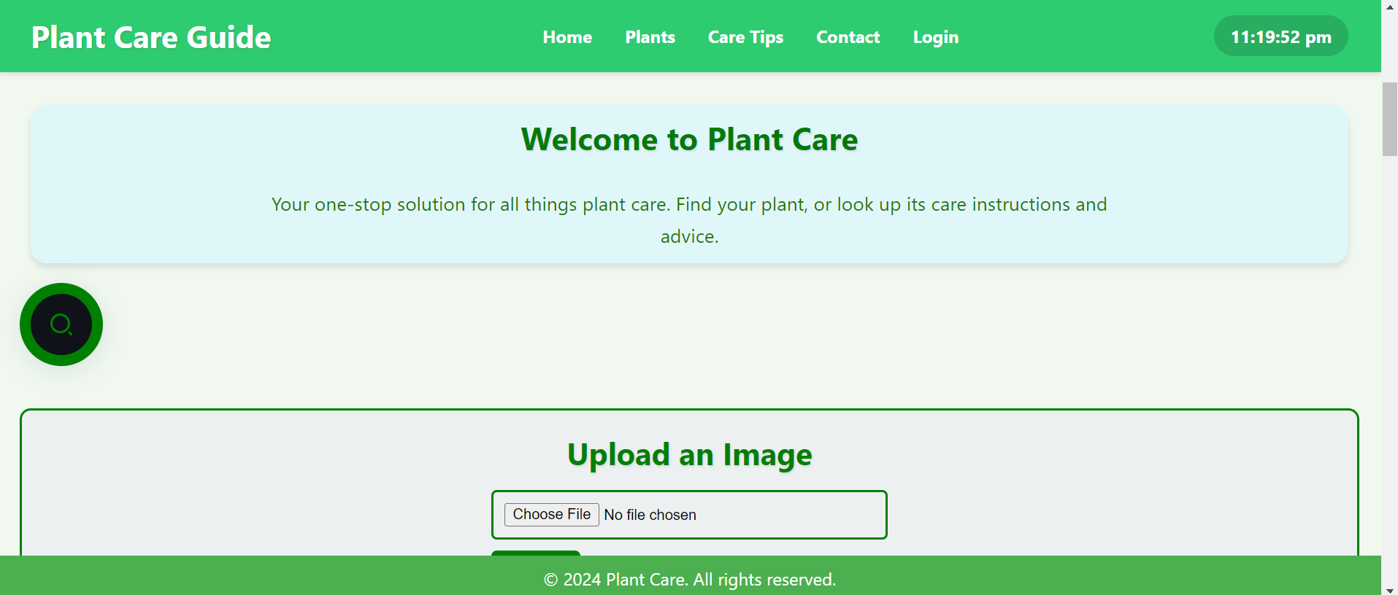

Fig. 7.3 Dashboard

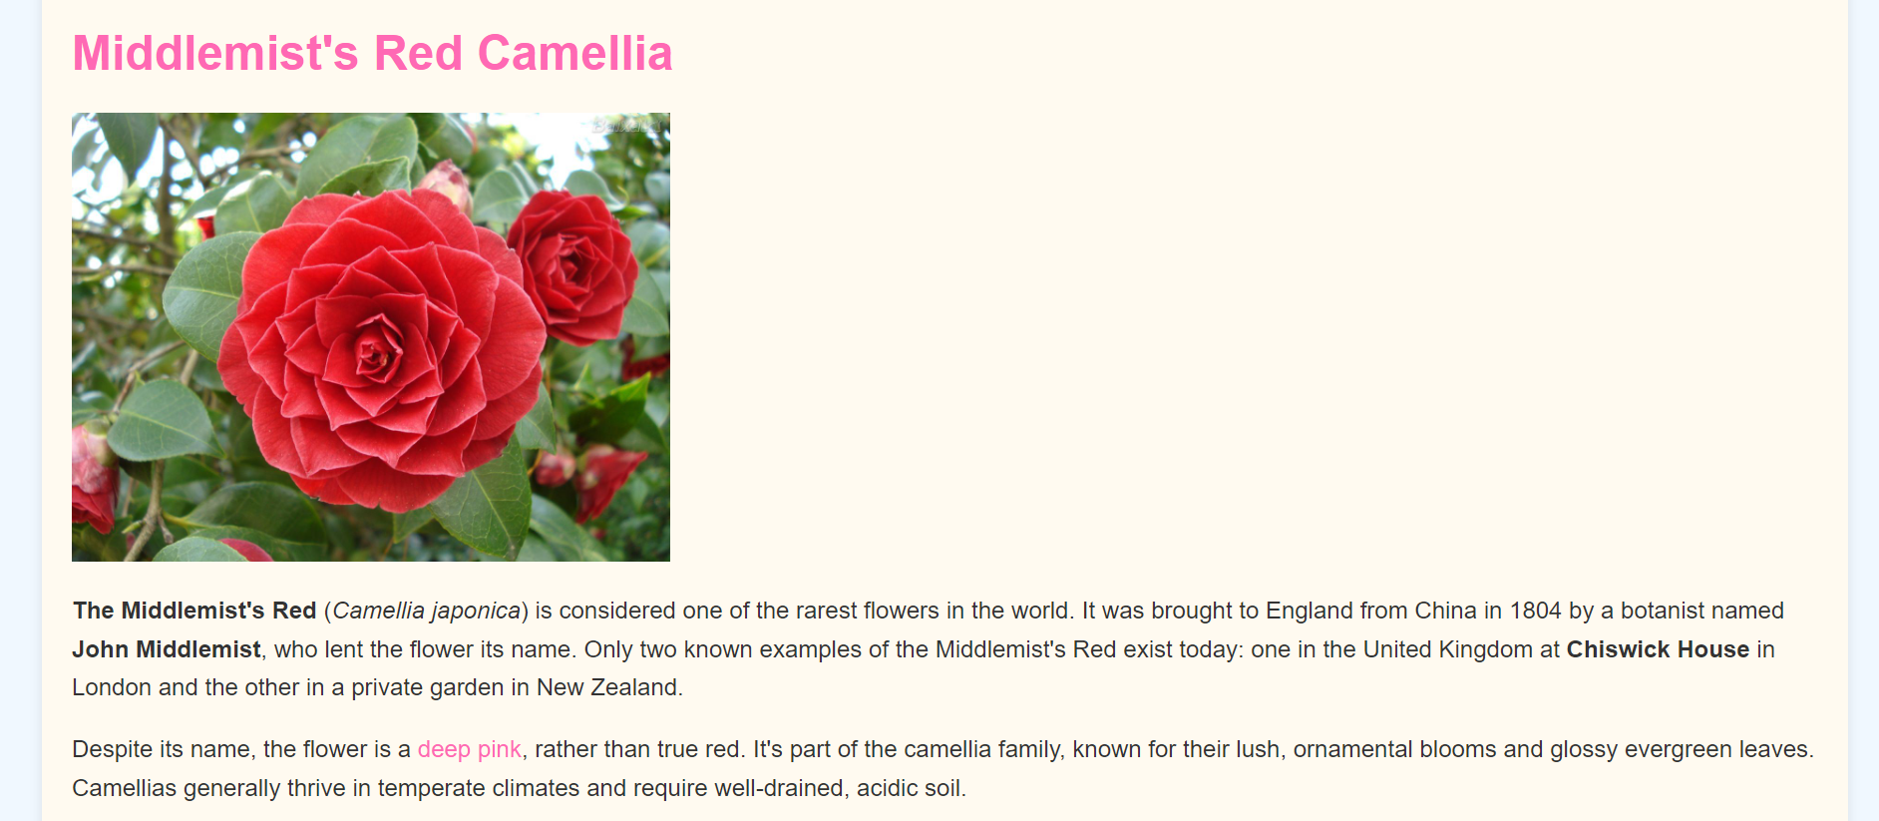

Fig. 7.4 Plant Information

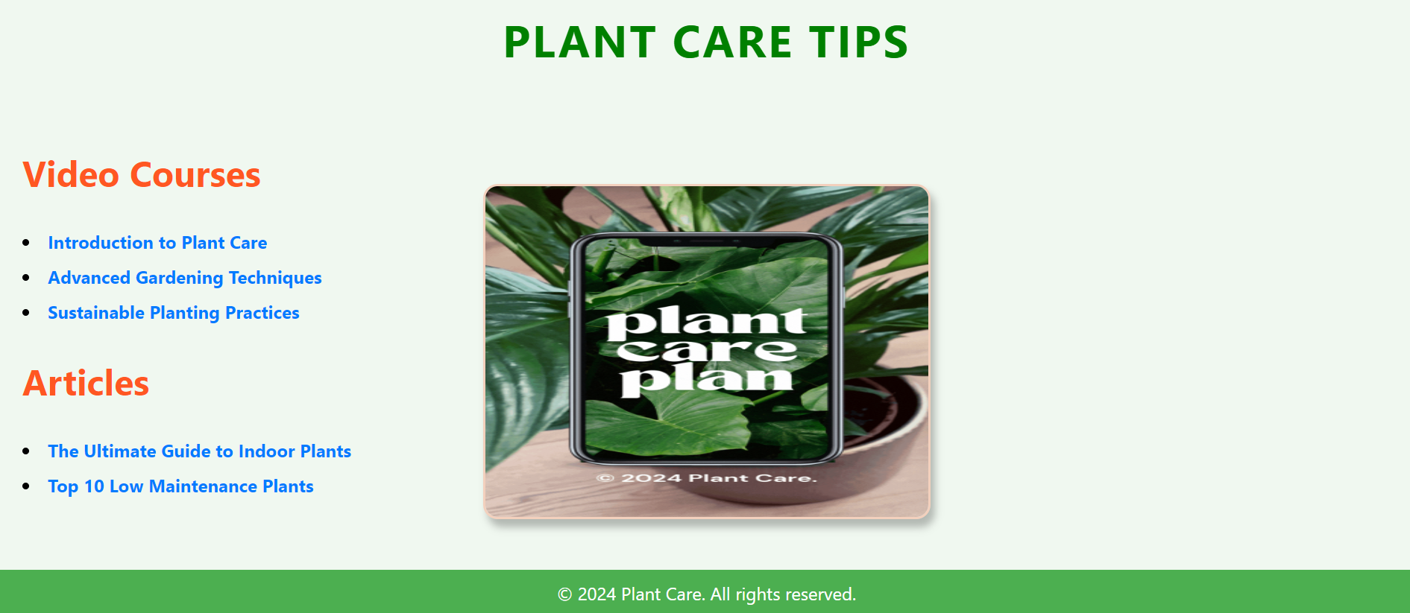

Fig. 7.5 Videos & Articles

### CHAPTER 8

#### CONCLUSION

In conclusion, the **Plant Care Guide** project serves as a comprehensive resource for plant enthusiasts and beginners alike. It provides valuable information on various aspects of plant care, including tips, resources, and an interactive platform for users to engage with their gardening interests.

With features such as an intuitive search function, the ability to upload images for identification and care guidance, and informative sections on rare plants and care tips, this project enhances the user experience by combining education with practical tools. The inclusion of video courses and articles further enriches the learning experience, making plant care accessible and engaging.

As we strive to foster a community of plant lovers, this platform not only offers a wealth of knowledge but also encourages individuals to take an active role in nurturing their plants. By empowering users with the right tools and information, the Plant Care Guide aims to promote a deeper appreciation for the beauty and benefits of plant life. Thank you for exploring the world of plants with us!

**REFERENCES**

1. HTML,CSS,JS– www.w3schools.com
2. PHP, MYSQL– www.youtube.com
3. Font Awesome Icons– [www.fontawesome.com](http://www.fontawesome.com)
4. Plant Details– [www.urbanplant.in](http://www.urbanplant.in)
5. PHP MY-ADMIN - https://www.phpmyadminonline.com/